The User Interface

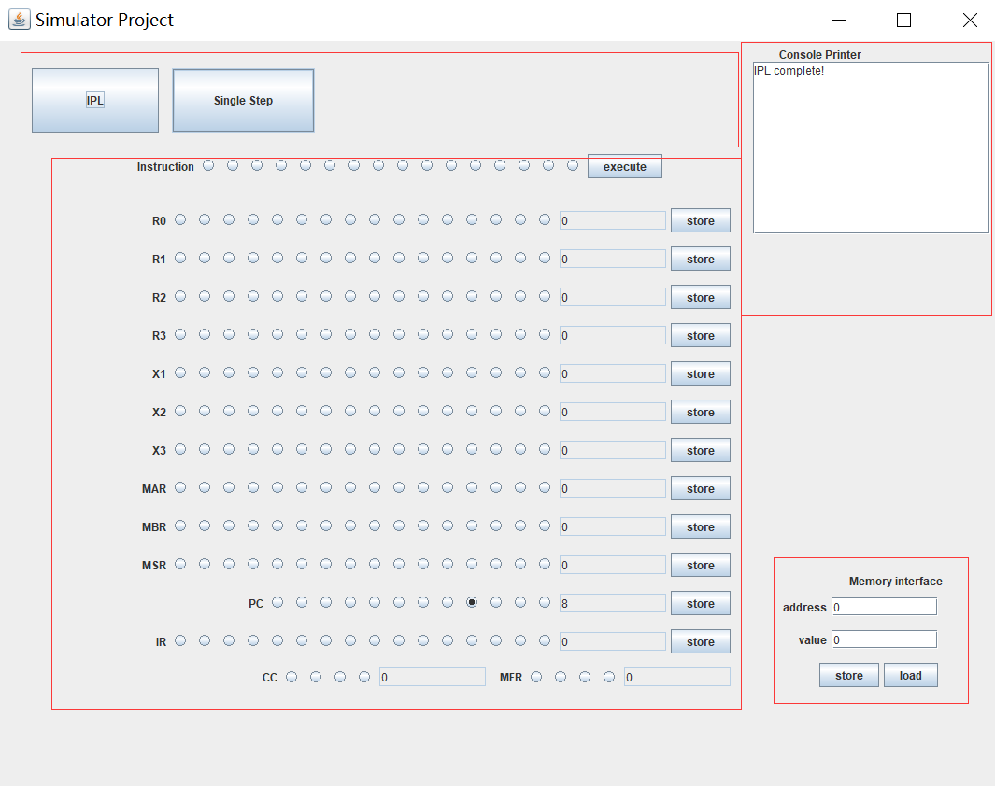

Figure 1: The User Interface of the simulator

**TOP Area**

**IPL Button** will reset the entire simulator. All data inside the memory and registers will be set to initial value. Load the file name ipl.txt to program.

**Single Button** will execute one instruction from the PC.

**Registers Area**

Most of the register value is editable, while some of the registers like IR, MFR, CC is not changeable.

To change the value of the register, type the value you want to set and press <store>

**Console Printer**

To show some message while program running

**Memory Area**

**Store Button** to store value to address in memory

**Load Button** to load value in address